Module 4: Introduction to Neural Networks
- What are Neural Networks?
A Neural Network is a machine learning model inspired by how the human brain works.
It is designed to recognize patterns, make decisions, and learn from data.
It’s widely used in image recognition, speech recognition, natural language processing, financial predictions, etc.

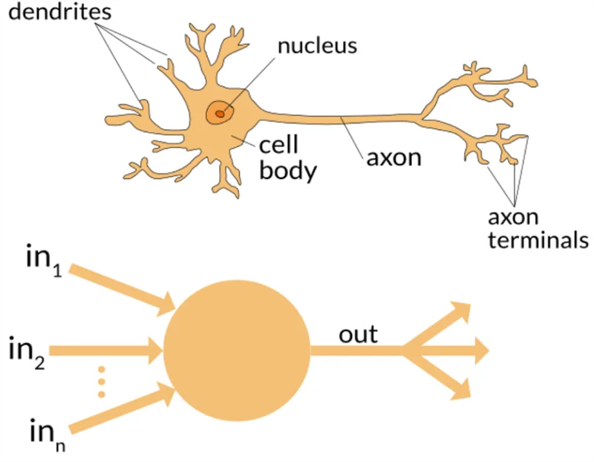

👉 In simple terms:
- Just like our brain has neurons connected together to process information, a neural network has artificial neurons (nodes) connected in layers.
- These nodes take inputs, apply weights and functions, and pass outputs forward — gradually learning to make accurate predictions.

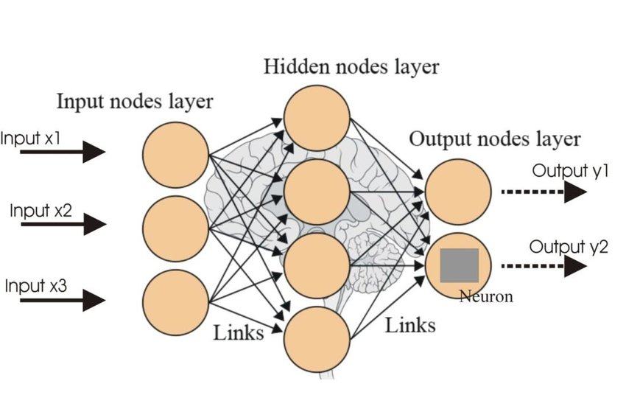

- Neural Network Architecture:

- Input Layer
  - Receives raw data (like numbers, images, text).
  - Example: pixel values of an image.
- Hidden Layers
  - Perform computations by combining inputs with weights and activation functions.
  - The more layers → the deeper the network → called Deep Neural Networks (DNNs).
  - Intermediate layers where the actual learning happens.

Weight = importance factor of an input.
The network learns weights automatically during training.
Adjusting weights is what makes the network smarter over time.
- Output Layer
  - Produces the final result (like classifying an email as spam or not spam).

(Output) z = (x1​×w1​) + (x2​×w2​) + bias

- x1 ​, x2 = input values
- w1 ​, w2 ​ = weights
- z = weighted sum (before activation function)
👉 If w1=0.9 and w2 = 0.1,
the network is saying x₁ is more important than x₂.
- (b) bias = extra adjustable value

A bias is an extra adjustable parameter added to the weighted sum of inputs before applying the activation function.
It allows the model to shift the output curve left or right, making the neuron more flexible in learning.
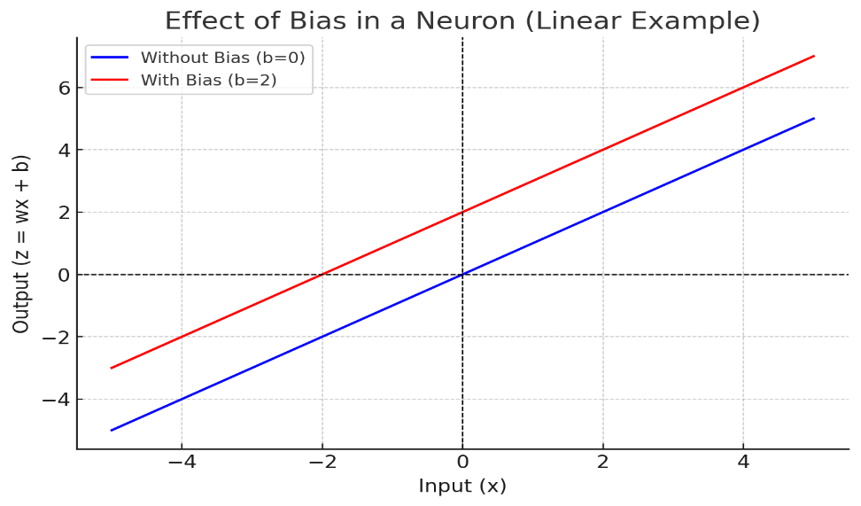
Blue line (b = 0) → output passes through the origin, no flexibility.
Red line (b = 2) → line shifts upward, thanks to bias.

How it Works (Step by Step):
- Input values enter the network.
- Each connection has a weight (importance of that input).
- A neuron computes:
Output = ActivationFunction (∑(Input×Weight) + Bias)
y=f( (xi​⋅wi​)+b)

- Data flows through layers, adjusting weights during training (via backpropagation) to reduce error.

Real-life Examples:
- Face recognition (unlocking phones).
- Spam filtering (email classification).
- Stock prediction (forecasting prices).
- Voice assistants (speech-to-text).

Example: A Tiny Neural Network (Predicts OR Gate)
An OR gate works like this:
- Input (0,0) → Output 0
- Input (0,1) → Output 1
- Input (1,0) → Output 1
- Input (1,1) → Output 1
We’ll make a neural network to learn this.

import numpy as np
# Activation function (sigmoid)
def sigmoid(x):
return 1 / (1 + np.exp(-x))
# Derivative of sigmoid (for training)
def sigmoid_derivative(x):
return x * (1 - x)
# Training data for OR gate
inputs = np.array([[0,0],
[0,1],
[1,0],
[1,1]])

outputs = np.array([[0],
[1],
[1],
[1]])

# Seed random numbers for consistency
np.random.seed(42)
# Initialize weights and bias randomly
weights = np.random.rand(2,1)
bias = np.random.rand(1)

# Learning rate
lr = 0.1

# Training loop
for epoch in range(10000):
# Forward pass
hidden_input = np.dot(inputs, weights) + bias
predicted_output = sigmoid(hidden_input)

# Calculate error
error = outputs - predicted_output

# Backpropagation (adjust weights)
adjustments = error * sigmoid_derivative(predicted_output)
weights += np.dot(inputs.T, adjustments) * lr
bias += np.sum(adjustments) * lr

# Final prediction after training
print("Final Weights:", weights)
print("Final Bias:", bias)
print("\nPredictions:")
print(predicted_output.round()) # Rounded to 0 or 1

This means the neural network learned OR logic 🎉

- Activation Functions
An activation function decides whether a neuron should be “activated” (fired) or not.
It takes the weighted sum + bias and transforms it into the neuron’s output.
👉 Without activation functions, a neural network would just behave like a simple linear equation (no matter how many layers).

Common Activation Functions
1. Sigmoid

f(Z) = 1 / (1 + e^(-Z))
f’(z) = f(z)*(1-f(z))
e≈2.71828

Output: between 0 and 1
- Good for probabilities
- Problem: vanishing gradient (very small updates for large values)

2. Tanh (Hyperbolic Tangent)

f(z) = tanh(z) = (e^z - e^-z) / (e^z + e^-z)
f’(z) = 1-(f(z)) ^2

e≈2.71828

- Output: between -1 and 1
- Centered at 0 → better than sigmoid for hidden layers.

  - ReLU (Rectified Linear Unit)

f(z)=max(0,z) =

f’(z) =

Output: 0 if z < 0, otherwise z
Very popular in deep learning (simple & efficient)
Problem: Dead ReLU (neuron stuck at 0 if weight updates fail).

  - Leaky ReLU (Parametric ReLU)

f(z)=

f(z) =

- Fixes “Dead ReLU” by allowing small negative slope.
Output range: ( )

  - Softmax (Combination of multiple sigmoids activation functions)
It calculates the relative probabilities.

Let’s suppose we have five output values of 0.8, 0.9, 0.7, 0.8, and 0.6
Here we can not use sigmoids as sum of all probabilities is more than 1.

f(zi​) =

e≈2.71828
- Converts a vector of numbers into probabilities (sum = 1).
- Useful for multi-class classification.

Let’s suppose there would be three neurons in the output layer. Output is [1.8, 0.9, 0.68].

Using softmax activation function for each value is [0.58, 0.23, 0.19]
Quick Intuition
- Sigmoid → squashes values to [0,1] → good for probability.
- Tanh → squashes values to [-1,1] → allows negatives.
- ReLU → fast, keeps positive values, kills negatives.
- Softmax → gives probability distribution across classes.

- Hands-On: Building a Simple Neural Network

Project: Stock Price Prediction using Neural Networks
import numpy as np
import tensorflow as tf
from tensorflow.keras.models import Sequential
from tensorflow.keras.layers import Dense
import matplotlib.pyplot as plt

# Example stock closing prices (can be replaced with real stock data)
stock_prices = np.array([110, 112, 115, 117, 120, 119, 121, 123, 125, 128, 130, 129, 131, 133, 136, 138, 137, 139, 142, 145])

# Create training data
# Use last 5 days to predict the next day's price
X = []
y = []

window_size = 5
for i in range(len(stock_prices) - window_size):
X.append(stock_prices[i:i+window_size])
y.append(stock_prices[i+window_size])

X = np.array(X)
y = np.array(y)

print("Input shape:", X.shape)

model = Sequential([
Dense(64, input_dim=5, activation='relu'), # Hidden Layer 1
Dense(32, activation='relu'), # Hidden Layer 2
Dense(1) # Output Layer (predict next price)
])

model.compile(optimizer='adam', loss='mean_squared_error')

model.fit(X, y, epochs=200, verbose=0)
print("✅ Training completed!")

# Take last 5 known prices
last_five_days = stock_prices[-5:]

predicted_prices = []

for _ in range(5): # Predict next 5 days
next_price = model.predict(last_five_days.reshape(1, -1))[0][0]
predicted_prices.append(next_price)
# Slide the window to include this predicted value
last_five_days = np.append(last_five_days[1:], next_price)

print("\n📈 Predicted next 5 days stock prices:")
print(predicted_prices)

# Combine actual and predicted prices for visualization
plt.figure(figsize=(8,4))
plt.plot(range(len(stock_prices)), stock_prices, label="Actual Prices")
plt.plot(range(len(stock_prices), len(stock_prices)+5), predicted_prices, 'r--', label="Predicted Prices")
plt.title("Stock Price Prediction using Neural Network")
plt.xlabel("Days")
plt.ylabel("Stock Price")
plt.legend()
plt.show()

